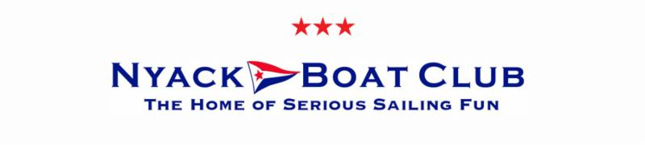
MEMBERSHIP APPLICATION

Date: _______________
Name: _____________________________________________________________
Address: _____________________________________________________________
______________________________________________ Zip ____________
E-Mail: _____________________________________________________________
Preferred phone: (_____) ________________

Date of birth: ________________________
Spouse name _______________________
Children less than 26 years old (name/age) ___________________________________ ______________________________________________________________________
Employer: _____________________________________________________________
Position: ______________________________________________________________

Type of boat owned: _____________________________________________________
If you do not own a boat presently, what type, if any, are you thinking of purchasing? ______________________________________________________________________

Boating experience: _____________________________________________________ ____________________________________________________________________________________________________________________________________________
______________________________________________________________________

Other hobbies and interests:_______________________________________________ ______________________________________________________________________

Why do you want to become a member of the Nyack Boat Club? __________________ __________________________________________________________________________________________________________________________________________________________________________________________________________________

The Nyack Boat Club is a do-it-yourself organization. As a member, how do you feel you could best participate in this aspect of the Club’s operation? __________________ __________________________________________________________________________________________________________________________________________________________________________________________________________________

How did you hear about the Nyack Boat Club? ________________________________
______________________________________________________________________

Members who sponsored you (optional):
1)__________________________________ 2)________________________________

If I am accepted as a member of the Nyack Boat Club, I agree to abide by its Constitution, By-Laws and Rules.
Signed: ___________________________
Date: ___________________________

Please return the completed application to:

NBC Admissions Committee or: admissions@nyackboatclub.org
59 Gedney Street
Nyack NY 10960

2022 membership application

